SQL with Pine Valley Furniture Company Database

1. Retrieve all fields from the customer table.

**Query:**

SELECT *

FROM CUSTOMER_t

;

**Output:**

1. **Retrieve the Product_Description, Product_Finish , Standard_Price, and Product_Line from the product table for the products in the product Line 2 .**

**SELECT**

**Product_Description, Product_Finish, Standard_Price, Product_Line**

**FROM**

**Product_t**

**WHERE**

**Product_line= 2**

**;**

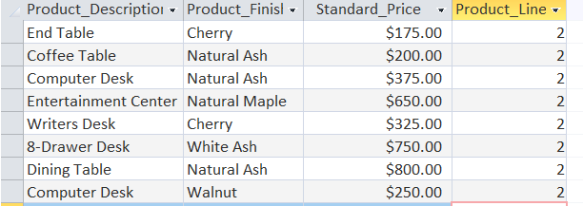

1. **Retrieve the Product_Description, Product_Finish , Standard_Price from the product table for those products which cost more than $200 AND have a Product_Finish of Natural Ash.**

**SELECT**

**Product_Description, Product_Finish, Standard_Price**

**FROM**

**Product_t**

**WHERE**

**Standard_Price>= 200**

**AND**

**Product_Finish = "Natural Ash"**

**;**

1. List customer ID, customer name, order ID, order date, product ID

and the quantity of each product ordered, for all customers who have placed orders.

SELECT

C.Customer_ID, C.Customer_Name, O.Order_ID, O.Order_Date, OL.Product_ID, OL.Ordered_Quantity

FROM

Customer_t C, Order_t O, Order_line_t OL

WHERE

C.Customer_ID= O.Customer_ID

AND

O.Order_ID= OL.Order_ID

;

1. List the customer name, order date, and product description for those customers who have purchased a Computer Desk.

SELECT

Customer_Name, Order_Date, Product_Description

From

Customer_t, Order_t, Order_line_t, Product_t

WHERE

Customer_t.Customer_ID=Order_t.Customer_ID

AND

Order_t.Order_ID=Order_Line_t.Order_ID

AND

Order_Line_t.Product_ID=Product_t.Product_ID

AND

Product_Description='Computer Desk'

;

1. **Which products were ordered before 10/22/2008? List the product name, the quantity ordered, and the order date for all orders placed before 10/22/2008.**

**SELECT**

**Product_Finish, Ordered_Quantity, Order_Date**

**FROM**

**Order_t, Order_Line_t, Product_t**

**WHERE**

**Order_t.Order_ID=Order_Line_t.Order_ID**

**AND**

**Order_Line_t.Product_ID=Product_t.Product_ID**

**AND**

**Order_Date <#10/22/2008#**

**;**

**7. How many products in Cherry have been ordered (i.e., the total number of units ordered)? List the product name, the product finish, and the total quantity ordered for each product with a Cherry finish.**

**SELECT**

**Product_Description, Product_Finish, SUM(Ordered_Quantity) AS [Quantity Ordered]**

**FROM**

**Order_Line_t, Product_t**

**WHERE**

**Order_Line_t.Product_ID=Product_t.Product_ID**

**GROUP BY**

**Product_Description, Product_finish**

**HAVING**

**Product_Finish= 'Cherry'**

**;**

**8.Which product lines have (include) two or less products? Your results should include the product line name and the number of products included in the product line.**

**SELECT**

**Product_Description, Product_Finish, SUM(Ordered_Quantity) AS [Quantity Ordered]**

**FROM**

**Order_Line_t, Product_t**

**WHERE**

**Order_Line_t.Product_ID=Product_t.Product_ID**

**GROUP BY**

**Product_Description, Product_finish**

**HAVING**

**Product_Finish= 'Cherry'**

**;**

**9.Which product lines have (include) two or less products? Your results should include the product line name and the number of products included in the product line.**

**SELECT**

**Product_line_name, Count(*) AS [Number Of Product]**

**From**

**Product_Line_t**

**GROUP BY**

**Product_line_name**

**Having**

**Count(*) <= 2**

**;**

**10. Write a nested query that will retrieve the product ID, product name, and product price for each product whose price is greater than the average price of all products.**

SELECT

Product_ID, Product_Description, Standard_Price

FROM

Product_t

WHERE Standard_Price >

(SELECT

AVG(Standard_Price) AS [Average Price]

FROM

Product_t)

;

